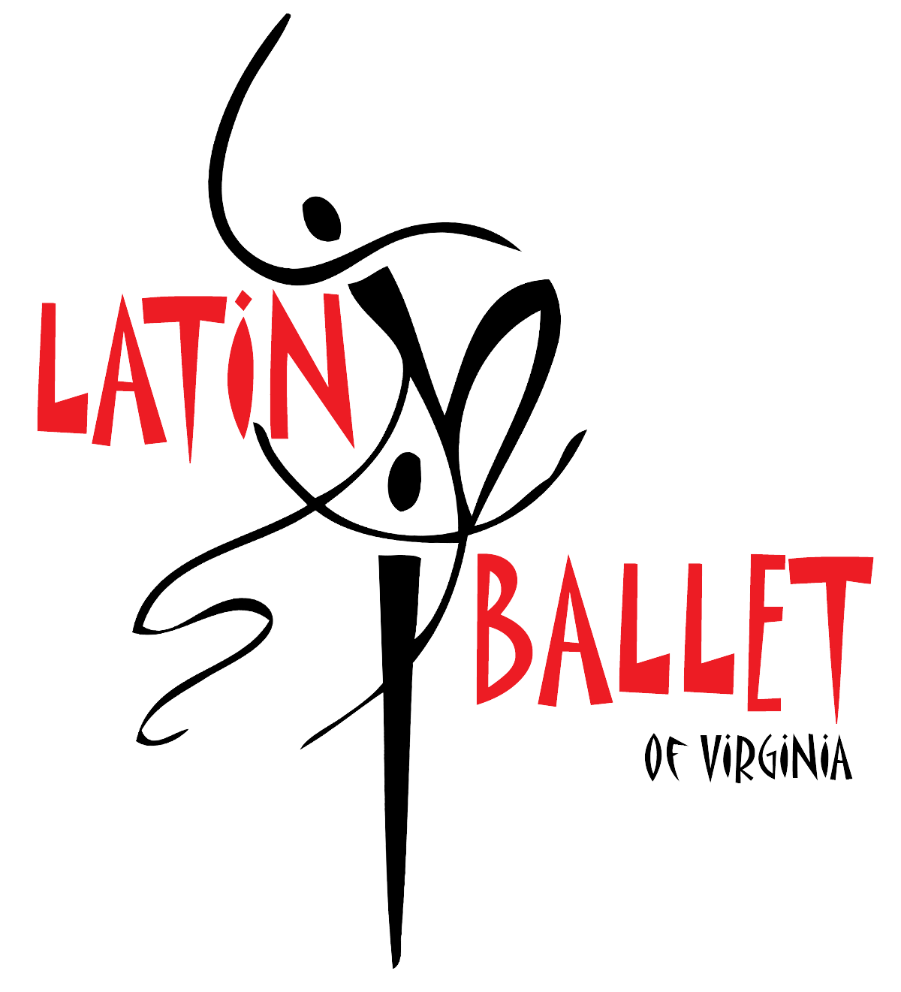
LATIN BALLET OF VIRGINIA
Your Ambassadors of Dance & Culture!

2880 Mountain Road Glen Allen, VA 23060 (804) 356.3856
www.latinballet.com
latinballet@latinballet.com

March 13, 2017

To Whom it May Concern:

Please excuse from class. They will be performing on stage in our historical dance theater production of of “NuYoRican”. We are proud and honored to have them
represent Latin Ballet of Virginia. The series of performances for “NuYoRican” include presentations during school times on Thursday, March 16th, 2017 at 10:30 am and Friday, March 17th at 10:30 am at the Cultural
Arts Center of Glen Allen. If you have any further questions or concerns, feel free to contact me anytime. Thank you for your time and efforts and have a great day!
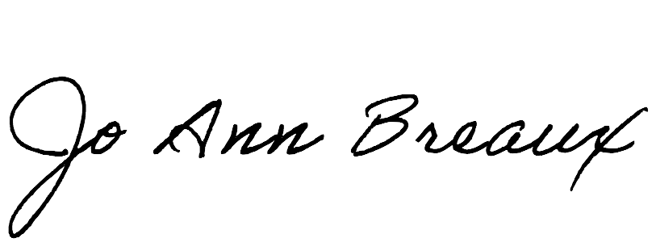
Sincerely,
Jo Ann Lee Breaux
Director of Operations and Marketing Manager
joann@latinballet.com 804.356.3876

,

